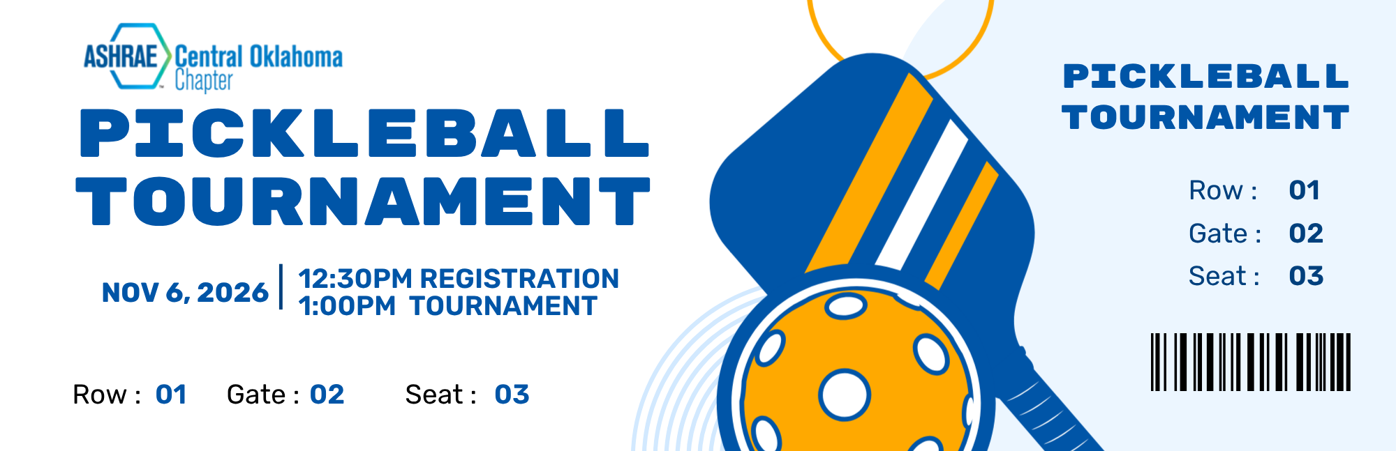

Team registration deadline is October 30, 2026 – however spots are limited so act fast! Sponsorship deadline is October 23, 2026.

REGISTRATION AND SPONSORSHIP OPTIONS
Team (32) $60 Double elimination, 2 players per team.

Tournament Sponsor (1) $1,000 Your logo printed on large signs on the back wall, sign at building entry, recognition as tournament sponsor at event and on social media, plus entry fee for (2) two teams.

Court Sponsor (6) $350 Large sign with your logo on your assigned court & 1 team.

*A portion of the proceeds will be donated to ASHRAE Research Promotions and to the Scholarship Endowment Fund.

Mail Check to:
Pay By Credit Card: $_____________
Company Name:
____________________________________

Email for invoice:
____________________________________

ASHRAE COK
Attn: Stephanie Thomas OR
6303 N Portland Ave Ste 302
Oklahoma City, OK 73112

PLAYER REGISTRATION:

Player #1: _________ _______ _______ Player #2:________ _ ______ ________

Team Name (be creative): _ _______ __________ ___________ ___

IMPORTANT:
We have moved locations!
This year the tournament will be at Northpark Pickleball, 12100 N May Ave.

